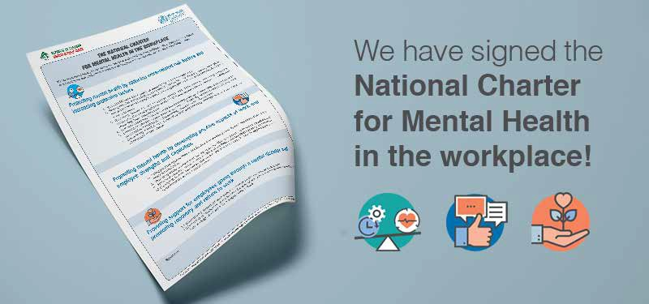

Dear Colleagues,

We are happy to let you know to we are now officially committed to provide us all with a mentally healthy work environment.

We have signed the “National Charter for Mental Health in the workplace” launched by the Ministry of
Public Health-National Mental Health Programme. View Charter

By signing this Charter we pledge to ensure a work environment that protects and promotes Mental Health. We will update you on future actions/activities related to this commitment which will be reflected in progress reports shared with the MOPH as well.

We will also be assigning a mental health in the workplace champion and sharing more information with you soon on their role.

For more information about the National Initiative for Mental Health in the Workplace

Visit Website

We hope all of you will be engaged with us for the success of the commitments within our organization,

(signed by the highest-level management)

